Press release from Association of Arctic Expedition Cruise Operators (AECO), the Icelandic Coast Guard (ICG) and the Joint Rescue Coordination Centre North Norway (JRCC NN) (for immediate release):
Report from Joint Arctic Search and Rescue Tabletop Exercise published
This week, the report from the most recent Joint Arctic Search and Rescue Tabletop Exercise was published. The report highlights how the skillset of expedition staff can be leveraged when establishing and evacuating passengers to a shore camp. The report also describes how vessels in distress, vessels of opportunity, search and rescue responders and home offices can work together to use available resources in the best possible way.
For the fifth year in a row, the Arctic expedition cruise industry, search and rescue sector and academia gathered for a joint tabletop exercise. The participants were invited to play out a scenario in which an expedition cruise vessel temporarily loses steering and grounds on a submerged shelf in a remote part of the Arctic. As the scenario progressed, the players were challenged to evacuate the unstable ship and establish a beach camp on shore. The report from the exercise highlights lessons learned and opportunities for further collaborations and learning across sectors.
Groups consisting of SAR responders, rescue coordination centre staff, ship officers, expedition staff, and the cruise operator home office collaborated to determine the challenges, constraints and opportunities involved in the proposed scenario. The report covers procedures and means of communication, collaboration and coordination, abandon ship procedures, crowd management techniques, efficient use of equipment, survival strategies, camp layout, and much more.
The Annual Joint Arctic Search and Rescue Tabletop Exercise (SAR TTX) is organized by the Association of Arctic Expedition Cruise Operators (AECO), the Icelandic Coast Guard (ICG) and the Joint Rescue Coordination Centre North Norway (JRCC NN). The overall objective is to enhance safety and preparedness in the Arctic maritime domain through strengthened collaboration between the Arctic expedition cruise industry, SAR entities and authorities.
This year, the exercise was organized as a fully virtual event on December 2-3, 2020, gathering nearly 130 participants from across the world. The Joint SAR TTX was attended by 26 AECO members and SAR entities from Canada, Iceland, Greenland, Faroe Islands, Svalbard, mainland Norway, USA, Finland, UK, and New Zealand. The event was organized under the umbrella of the Arctic and North Atlantic Security and Emergency Preparedness Network (ARCSAR) with funding from the European Union’s Horizon 2020 research and innovation programme.

Suggested illustration photo
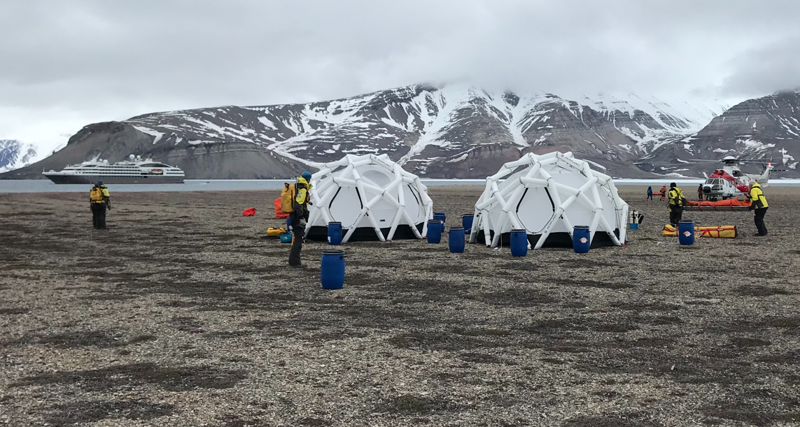 | Photo caption: The virtual exercise contained a scenario where crew and passengers had to seek shelter ashore. This photo shows a shore camp from a previous SAREX live exercise in Svalbard. Photo by Brede Valanes, AECO.  High resolution illustration image can be downloaded here:  https://www.dropbox.com/sh/276ajwou6mphn2r/AAA4nErC1mtmb9v63yaDlrUDa?dl=0
Contact
Edda Falk, Communications manager
AECO - Association of Arctic Expedition Cruise Operators
edda@aeco.no | Cell: +47 476 32 550

AECO - Association of Arctic Expedition Cruise Operators
Association of Arctic Expedition Cruise Operators is an international organization for expedition cruise operators and associates in the Arctic, dedicated to managing environmentally friendly, safe and considerate cruise tourism. With close to 70 international members – including 50 vessel operators, owners and management, and over 60 expedition cruise vessels that are organized by the association – AECO represent the great majority of these operations in the Arctic.
Website: www.aeco.no.
Joint Rescue Coordination Centre North Norway
Norwegian rescue services are carried out through cooperation between government agencies, voluntary organizations and private companies who have resources appropriate for rescue services. The Joint Rescue Coordination Centre (JRCC) North Norway has the overall operational responsibility during search and rescue operations in its area of responsibility, which stretches from 65°N to the North Pole. JRCC North-Norway is located in Bodø.
Website: https://www.hovedredningssentralen.no/english/
Icelandic Coast Guard
The Icelandic Coast Guard (ICG) is a law enforcement agency that is responsible for search and rescue, maritime safety and security surveillance, and law enforcement in the seas surrounding Iceland. The ICG's operations are based on gathering, analysing and distributing information in close cooperation with neighbouring countries in order to create a surface picture as accurate as possible at any given moment to ensure maritime safety and security.
Website: http://www.lhg.is/english/

