Press release from AECO - Association of Arctic Expedition Cruise Operators and the International Association of Antarctica Tour Operators (IAATO) (for immediate release):
Polar tour operators participate in third annual Cleanup for Sarah
People worldwide will be picking litter on beaches, in cities and in their communities for the third year in a row in memory of Sarah Auffret, a beloved member of the polar travel community
On June 12-20, the global “Clean-up for Sarah” will take place in honor of Sarah Auffret, a victim of the Ethiopian Airlines crash on March 10, 2019.
In addition to working as polar guide, expedition leader and Antarctic base leader, Sarah had a long-standing passion for environmental issues. She led the expedition cruise industry’s efforts to combat marine plastic litter through her positions as environmental agent for the Association of Arctic Expedition Cruise Operators (AECO). To mark her birthday on June 16, people around the world have participated in clean-up actions every year since 2019.
Frigg Jørgensen, Executive Director of AECO, says that it is very fitting for Sarah’s memory to be honored in this way.
“The polar travel industry is a global community that is brought together by our love of the polar regions with their unique natural environments, cultures and history,” says Jørgensen.
“The pandemic has put a temporary halt to our activities and separated people who are used to coming together to create meaningful and educational experiences through polar travel. While we are spread out across the world, these shared clean-up efforts remind us of the impact that we can have and how we can be part of the solution to environmental challenges. Sarah is an example of how one person could touch the lives of so many people and inspire change.”
Gina Greer, IAATO Executive Director, said: “Sarah was an ambassador not just for the polar regions but the world’s oceans, and her legacy lives on through our actions.”
Both AECO and International Association of Antarctica Tour Operators (IAATO) are encouraging their members to contribute to cleanup efforts as well as the reduction of single-use plastics. Both associations encourage participants to share their actions on social media, using the event hashtag #CleanupforSarah.
This year’s clean-up will take place worldwide and will be tracked on an interactive map. In previous years, cleanups were organized in Alaska, Greenland, Svalbard, Iceland, Ushuaia, Argentina, South Georgia, Australia, Japan, England, the US and a number of other locations.

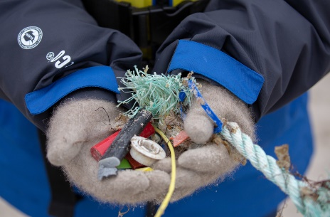
Illustration photo
Caption: Marine litter collected in polar areas. Photo by Michael Baynes, Aurora Expeditions
Illustration photo can be downloaded here.

AECO - Association of Arctic Expedition Cruise Operators
The Association of Arctic Expedition Cruise Operators is an international organization for expedition cruise operators and associates in the Arctic, dedicated to managing environmentally friendly, safe and considerate cruise tourism. With around 70 international members, including 47 vessel operators, owners and management, AECO represent the great majority of these operations in the Arctic. AECO works to ensure that expedition cruises and tourism in the Arctic is carried out with the utmost consideration for the vulnerable, natural environment, local cultures and cultural remains, as well as the challenging safety hazards at sea and on land.
Contact
Edda Falk, communications manager, AECO
edda@aeco.no | Cell: +47 47 63 25 50
www.aeco.no
International Association of Antarctica Tour Operators (IAATO)
IAATO is a member organization founded in 1991 to advocate and promote the practice of safe and environmentally responsible private-sector travel to the Antarctic. IAATO has over 100 members who work together to develop and implement operational standards that mitigate potential environmental impacts. Numerous procedures, guidelines and membership requirements adopted over the last 30 years have proven to be successful methods in avoiding such impacts.
Contact
Hayley Collings. Communications & Engagement Manager, IAATO
hcollings@iaato.org
www.iaato.org

