

Press release from AECO - Association of Arctic Expedition Cruise Operators (for immediate release):

Community engagement key to a responsible return to Arctic expedition cruising

February 5, 2021, Tromsø, Norway

Once Arctic coastal communities are ready to welcome tourists again, expedition cruise operators can engage with local communities to plan safe and considerate visits. The Association of Arctic Expedition Cruise Operators (AECO) is working to identify best practices for responsible community engagement in the COVID-19 era.

The 2020 Arctic cruise season was severely impacted by the COVID-19 pandemic. As a result, many Arctic coastal communities lost an important source of income. As vaccination progresses, both communities and operators are preparing for the time when it will be safe to travel again. While waiting for operations to resume, the Arctic expedition cruise industry is preparing. Dialogue with local communities is an important part of this effort.

To facilitate dialogue between operators and local stakeholders, AECO has developed an infographic which outlines important principles for responsible community engagement. According to Frigg Jørgensen, executive director of the Association of Arctic Expedition Cruise Operators, community engagement is more important than ever.

“We know that many communities eagerly await the time when they can again welcome travellers, along with the income and job opportunities that tourism brings. At the same time, communities need to feel confident that the reopening is safe and well-regulated. Going forward, the expedition cruise industry will continue to work with local communities when it comes to COVID-19 mitigation. Good, transparent communication is essential, in addition to adapting national and regional measures and protocols, and the sentiment of the community in question,” says Jørgensen.

Throughout the pandemic, AECO has worked closely with authorities and community representatives to ensure a safe resumption of Arctic cruising. While the timeline for reopening of Arctic destinations is not yet clear, Jørgensen stresses that the expedition cruise industry is doing its part by making sure that safety protocols are rigorous and updated to reflect the latest scientific knowledge and technological advances.

Suggested illustration photo
High resolution illustration image can be downloaded here:
https://www.dropbox.com/sh/rwnnxmx4m3khl05/AAD4V-_9ZtZctTe0-zPDtnuDa?dl=0
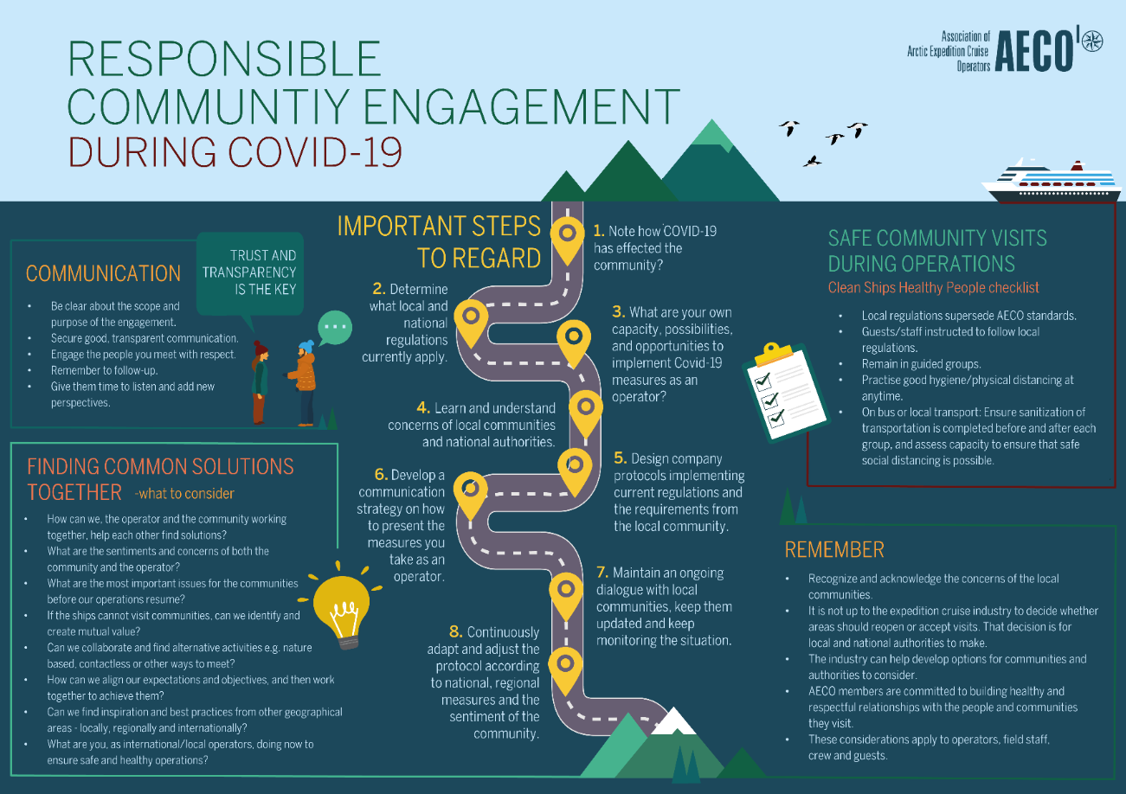

Contacts
Edda Falk, communications manager, AECO - Association of Arctic Expedition Cruise Operators edda@aeco.no | Cell: +47 476 32 550 | www.aeco.no

AECO - Association of Arctic Expedition Cruise Operators
The Association of Arctic Expedition Cruise Operators is an international organization for expedition cruise operators and associates in the Arctic, dedicated to managing environmentally friendly, safe and considerate cruise tourism. With around 70 international members, including 47 vessel operators, owners and management, AECO represent the great majority of these operations in the Arctic. AECO works to ensure that expedition cruises and tourism in the Arctic is carried out with the utmost consideration for the vulnerable, natural environment, local cultures and cultural remains, as well as the challenging safety hazards at sea and on land.
Website: www.aeco.no.

