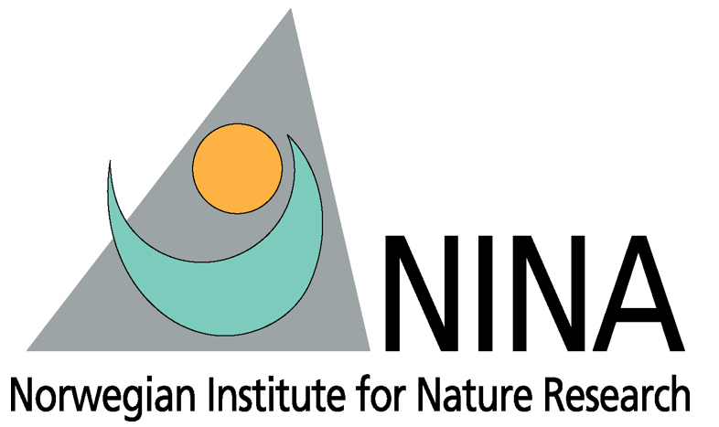

Press release from AECO - Association of Arctic Expedition Cruise Operators, Norwegian Institute for Nature Research (NINA) and Visit Svalbard (for immediate release):

New report encourages research to support Arctic tourism management

January 8, 2020, Longyearbyen, Svalbard

Arctic tourism stakeholders have contributed to a report that outlines knowledge gaps and research needed to support responsible tourism management in the Arctic. The goal is to encourage researchers to undertake research that can inform decision-makers, local communities and operators in a time of increased interest in Arctic tourism.

The report points to research needs and suggested studies ranging from exploring technological innovations can be relevant for tourism to reviewing the legal framework regulating tourism in Svalbard. On the preparedness side, the report calls for more research on the organization of emergency reception camps on land or on another vessel in case of mass evacuation, among other things. One of the main challenges identified in the report is the risks associated with unorganized tourism, which has the potential to negatively impact on organized tourism, environment, local community and safety.

The report proposes a number of possible solutions to challenges connected with tourism. Some of the solutions proposed by researchers and stakeholders include the following:

- Tools and policies to ensure sustainable management of visitors, which could include mapping sensitive areas, enhanced management of capacity thresholds, and a holistic consideration of the number of visitors as well as their distribution by category, season and activity.
- Enhanced management of private sail boats and yachts.
- Mandatory training and certification of all guides.
- Using drones to map impact of tourism and traffic on vegetation.

The workshop participants also highlighted the fact that well-organized tourism should be considered as an opportunity and a possible solution to potential challenges. According the participants, which included many local stakeholders, societal challenges can be managed by ensuring local value creation, strengthening infrastructure, well-coordinated destination management, identifying and attracting optimal clients and generating empirical knowledge about tour operators, visitors and people of Longyearbyen.

The report is the result of a workshop that took place Longyearbyen, Svalbard this fall. The event gathered over 50 participants including key researchers from a broad range of fields. These included social science, economics, natural sciences, business, tourism, Arctic issues and preparedness. Representatives from research funding institutions and those working in tourism were also present. The objective of the gathering was to discuss, define and pitch research projects that can help Svalbard find the optimal balance in tourist development. The event has been made possible with funding support from Svalbard Environmental Protection Fund.

According to Trine Krystad of Visit Svalbard, the workshop is part of a wider effort to contribute to knowledge-based tourism management in the Arctic.

“When we talk about sustainable tourism, we need to consider all aspects of how tourism can impact and benefit the Arctic. This includes everything from environment, communities, local benefits, safety and preparedness. We invited researchers from different fields, industry, authorities, locals and funding institutions to help us map the areas and issues that we need to focus on now and in the future. We were impressed to see how these stakeholders representing different industries and research disciplines were able to come together to tackle these important questions. The report shows that this cross-sectoral approach was very successful,” says Krystad.

According to Frigg Jørgensen, executive director of AECO, the organizers hope that researchers will make use of the suggestions outlined in the report.

“We know that Arctic tourism is a topic of interest for many research environments. We encourage researchers to consult this list of topics identified by local and tourism stakeholders. This is a chance to carry out research that will be actively used by decision-makers and end-users,” says Jørgensen.

A summary of research needs as well as the full workshop report are available on the websites of AECO and Visit Svalbard. Both organizations are eager to collaborate with research projects that focus one the areas and knowledge gaps identified in the report.

Suggested illustration photo
High resolution illustration image can be downloaded here:
https://www.dropbox.com/sh/s5bqlf5uicp6t7l/AABFRx9Un735bpOqKKPiWwmca?dl=0
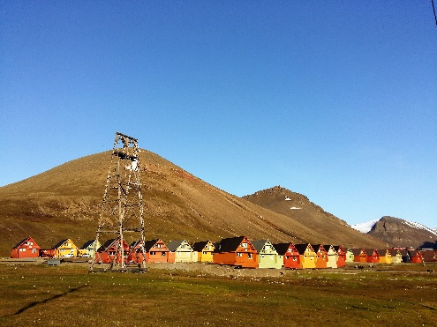 | The report outlines knowledge gaps and research needed to support responsible tourism management in Svalbard. Photo: Frigg Jørgensen, AECO.

Contacts
Edda Falk, communications manager, AECO - Association of Arctic Expedition Cruise Operators edda@aeco.no | Cell: +47 476 32 550 | www.aeco.no
Trine Krystad, Visit Svalbard
trine@visitsvalbard.com | Cell: +47 952 73 473 | https://en.visitsvalbard.com/
Bjørn Kaltenborn, Senior Research Scientist, NINA
bjorn.kaltenborn@nina.no | Cell: +47 934 66 707 | www.nina.no/english

AECO - Association of Arctic Expedition Cruise Operators
Association of Arctic Expedition Cruise Operators is an international organization for expedition cruise operators and associates in the Arctic, dedicated to managing environmentally friendly, safe and considerate cruise tourism. With 75 international members – including 46 vessel operators, owners and management, and 60 expedition cruise vessels that are organized by the association – AECO represent the great majority of these operations in the Arctic.
Website: www.aeco.no.
Visit Svalbard
Visit Svalbard AS is owned by Svalbard Reiselivsråd, which is a member-based organization for the travel industry in Svalbard. The company’s vision if for Svalbard to be the world’s leading and best preserved High Arctic travel destination. This will be achieved through deliberate development based on and considerate of the peninsula’s fragile nature, with a focus of environment and knowledge-based tourism. Visit Svalbard’s activities include marketing, promotion and selling Svalbard as a destination. Visit Svalbard also functions as a secretariat for all of the travel industry in Longyearbyen.
Website: www.visitsvalbard.com
Norwegian Institute for Nature Research (NINA)
Norwegian Institute for Nature Research (NINA) is an independent foundation for nature research and research on the interaction between human society, natural resources and biodiversity. NINA has 265 employees divided between the main office in Trondheim and departments in Tromsø, Bergen, Lillehammer and Oslo.
Website: https://www.nina.no/english/Home
Svalbard Environmental Protection Fund
The Svalbard Environmental Protection Fund was established in 2001 under the Svalbard Environmental Protection Act. The fund's resources will be used to initiate and stimulate projects with the purpose of protecting Svalbard’s environment. The fund is financed by dues and allocation, including the environmental fee paid by all visitors to Svalbard.
Website: http://www.sysselmannen.no/en/Svalbard-environmental-protection-fund/News/Svalbardenvironmental-protection-fund-/

