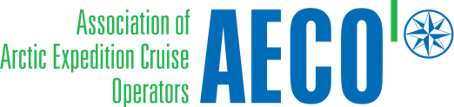

Press release from AECO - Association of Arctic Expedition Cruise Operators (for immediate release):

Expedition cruise sector continues to combat plastic waste in the Arctic

November 27, 2019

New survey results have been released of the Arctic expedition cruise industries efforts to combat marine plastic pollution, including the reduction of single-use plastic onboard and organizing beach cleanups.

The Association of Arctic Expedition Cruise Operators (AECO) is working with cruise operators to tackle plastic waste on board ships as well as at the remote Arctic locations they visit.

In 2018, AECO conducted a survey of its members to determine the industries efforts to combat marine plastic pollution. A new follow up survey is tracking progress on the reduction of single-use plastic onboard and efforts to organizing beach cleanups.

Survey results show that AECO’s members are highly involved in beach cleanups in Svalbard with about 80% of survey respondents indicating that they participated in Clean Up Svalbard this past season as well as last year. These members organized dedicated beach cleanups with passengers, staff and crew as part on their shore excursions on all or some of their voyages. Cleanups also took place this past season in other Arctic regions, such as Greenland and Canada.

The new survey results indicate that nearly all survey respondents have made efforts to reduce single-use items onboard, with most efforts being focused in the restaurant and bar as well as the hotel department. According to those surveyed, the most significant challenges in reducing single-use waste is the availability of alternative goods in ports. This challenge AECO hopes to overcome in the future to ensure single-use plastic is reduced onboard.

In May, AECO released guidelines to help passengers reduce their single-use waste while traveling to the Arctic. The guidelines outline measures that can be taken before, during and after their trip. Survey results indicate that more than two thirds of respondents have used AECO’s Clean Seas Guidelines for Visitors to the Arctic.

According to Frigg Jørgensen, executive director of AECO, the association’s members have embraced the Clean Seas Project.

“We’re very pleased to see that our members are more eager than ever to combat marine plastic pollution. In addition to carrying out cleanups, AECO members are working to educate guests about this issue. We also see that operators are making great efforts to replace single-use items on ships with more sustainable options, ” says Jørgensen.

Contacts
Edda Falk, communications manager, AECO - Association of Arctic Expedition Cruise Operators edda@aeco.no | Cell: +47 476 32 550 | www.aeco.no

Suggested illustration photo

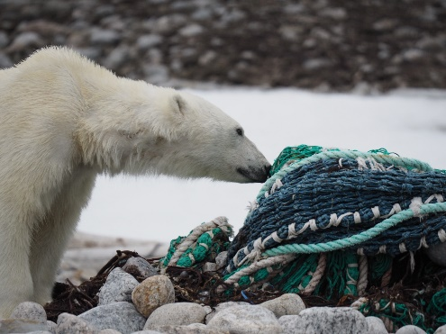 | Photo caption: Marine litter, such as these discarded fishing nets, can have a negative impact on Arctic wildlife.  Photo: Zet Freiburghaus, Polar Quest
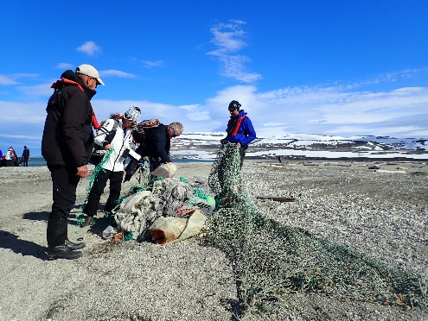 | Photo caption: Passengers participating in cleanups of Arctic beaches.  Photo: Zet Freiburghaus, Polar Quest
High resolution illustration images can be downloaded here:
https://www.dropbox.com/sh/s6q2mbon1iojobt/AABi8vL00-SP3Ft6q5ncMv7ia?dl=0

AECO - Association of Arctic Expedition Cruise Operators
Association of Arctic Expedition Cruise Operators is an international organization for expedition cruise operators and associates in the Arctic, dedicated to managing environmentally friendly, safe and considerate cruise tourism. With close to 70 international members – including 40 vessel operators, owners and management, and 50 expedition cruise vessels that are organized by the association – AECO represent the great majority of these operations in the Arctic. Website: www.aeco.no.
Learn more about AECO’s Clean Seas efforts here: https://www.aeco.no/clean-seas/

The Clean Seas campaign
UN Environment launched #CleanSeas in February 2017, with the aim of engaging governments, the general public, civil society and the private sector in the fight against marine plastic litter. Over the next five years, the campaign will address the root-cause of marine litter by targeting the production and consumption of non-recoverable and single-use plastic. By connecting individuals, civil society groups, industry and governments, UN Environment aims to transform habits, practices, standards and policies around the globe to dramatically reduce marine litter and the harm it causes. Website: http://www.cleanseas.org/

Clean up Svalbard
Clean up Svalbard is a joint effort to remove waste from the shores of Svalbard. Waste is carried by ocean currents and washes ashore in the Svalbard archipelago. For almost 20 years, inhabitants and visitors have been encouraged to pick up marine debris when they visit the coast. Almost 20 years ago, an expedition cruise company saw an opportunity to help clean up marine debris around Svalbard during voyages. The operator approached the Governor of Svalbard who offered logistical support to handle the waste. Clean up Svalbard was born, and more AECO members and local organizations got involved. In recent years, about 20 tons of waste have been removed from beaches in Svalbard every summer. Expedition ships remove between 3 – 4 tons per season. The Governor of Svalbard organizes dedicated cleanup trips for locals twice a year while other local associations hold additional events, mainly in Isfjorden. According to studies of the collected waste in 2016 and 2017, 60-80% of it comes from the fishery industry.

