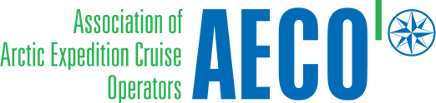

Press release from AECO - Association of Arctic Expedition Cruise Operators (for immediate release):

AECO’s Arctic Cruise Conference brings community engagement to the forefront

The Association of Arctic Expedition Cruise Operators (AECO) is holding its yearly event in Oslo, bringing together leading experts to discuss matters relating to environment, safety and community engagement.

October 14, 2019, Oslo, Norway

More than 120 participants will gather in Oslo for AECO’s Arctic Cruise Conference, organized for the 16th year in a row. The program of this year’s event will contain a comprehensive range of topics including marine preparedness and search and rescue, as well as destination updates from Svalbard, Greenland, Canada, Russia, Iceland and Antarctica.

The conference also highlights community engagement, a key priority for the Arctic expedition cruise industry and AECO. Industry representatives and local stakeholders will present how cruise tourism can bring local benefits to Arctic communities. Presentations will address how the small community of Longyearbyen has met the challenges and opportunities connected with cruise calls and the what the recent Svalbard Cruise Study reveals about local spending. The participants will also learn how Greenlandic communities are planning to use community specific guidelines to enhance their communication with visiting cruise operators.

Frigg Jørgensen, AECO’s Executive Director explains that community engagement is a prioritized area for the association’s members:

“Cruise operators rely on the hospitality of the communities that they visit, and it is important that cruise calls are a positive experience for everyone involved. Sustainable tourism should be both respectful of local culture and bring benefits to the people of the Arctic,” says Jørgensen, who herself is a resident of Longyearbyen, Svalbard.

In conjunction with the conference, AECO is organizing side meetings focused on maritime issues, developments in Svalbard.

Suggested illustration photo
High resolution illustration image can be downloaded here:
https://www.dropbox.com/sh/qlrm6v8kwx9zf30/AADtWrBCaA4iHDGeX66oULV3a?dl=0
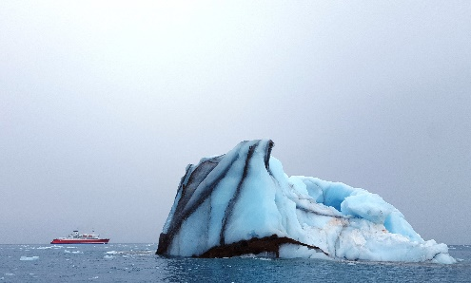 | AECO’s Arctic Cruise Conference is organized for the 16th year in a row Photo: Ilja Leo Lang, AECO
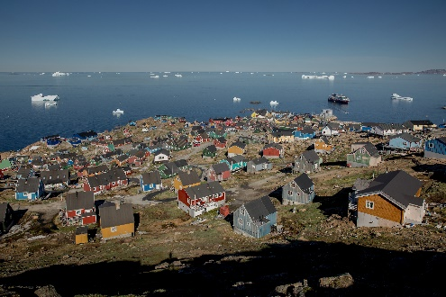 | Community engagement is one of the focus areas of this year’s Arctic Cruise Conference. Photo showing the community of Upernavik, Greenland. Photo: Mads Pihl, Visit Svalbard.
 | Participants at the Arctic Cruise Conference. Photo: AECO.

Contacts
Edda Falk, communications manager, AECO - Association of Arctic Expedition Cruise Operators edda@aeco.no | Cell: +47 476 32 550 | www.aeco.no
AECO - Association of Arctic Expedition Cruise Operators
Association of Arctic Expedition Cruise Operators is an international organization for expedition cruise operators and associates in the Arctic, dedicated to managing environmentally friendly, safe and considerate cruise tourism. With 75 international members – including 46 vessel operators, owners and management, and 60 expedition cruise vessels that are organized by the association – AECO represent the great majority of these operations in the Arctic.
Website: www.aeco.no.

