

Press release from AECO - Association of Arctic Expedition Cruise Operators (for immediate release):

AECO’s Arctic Cruise Conference donates to Tara Ocean Foundation

This year, participants of the 2019 Arctic Cruise Conference were not only invited to enjoy the traditional Annual Dinner of the Association of Arctic Expedition Cruise Operators (AECO). Thanks to Silversea Cruises, the dinner was a charitable fundraiser for the Tara Ocean Foundation.

October 17, 2019, Oslo, Norway

Representatives from the expedition cruise industry, Arctic stakeholders, authorities and researchers gathered in Oslo this week for AECO’s Arctic Cruise Conference. In addition to the conference and side meetings, attendants were invited to be part of AECO’s traditional Annual Dinner, which took place October 16.

For the second year in a row, AECO’s Annual Dinner is sponsored by Silversea Cruises, which offers intimate luxury cruising to the polar regions and other destinations. This year, Silversea Cruises took the initiative to convert the dinner to a fundraiser in support of environmental stewardship in the Arctic.

Silversea covered the entire cost of the dinner and suggested the participants make a donation to the Tara Ocean Foundation, which resulted in a contribution of NOK 22 000 (USD 2500).Tara Ocean Foundation organizes voyages to study and understand the impact of climate change and the ecological crisis facing the world's oceans.

According to AECO’s Executive Director Frigg Jørgensen, the association’s members are passionate about protecting the Arctic regions that they visit.

“We are grateful for this generous sponsorship of Silversea Cruises. They suggested using the occasion to raising funds for an environmental cause, which we think was an excellent idea. We would like to thank every participant for their donation to Tara Ocean Foundation,” says Jørgensen.

Suggested illustration photo
High resolution illustration image can be downloaded here:
https://www.dropbox.com/sh/hpiwzq8m0cr07uk/AAAqdI3D9cH6lwGx4ICb3OoFa?dl=0
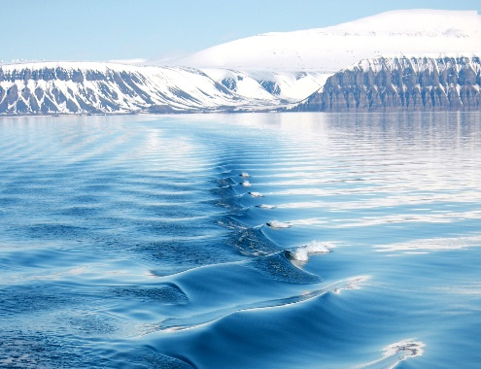 | Tara Ocean Foundation, which organizes voyages to study and understand the impact of climate change and the ecological crisis facing the world's oceans. Photo from Isfjorden, Svallbard. Photo by Ilja Leo Lang, AECO

Contacts
Edda Falk, communications manager, AECO - Association of Arctic Expedition Cruise Operators edda@aeco.no | Cell: +47 476 32 550 | www.aeco.no
AECO - Association of Arctic Expedition Cruise Operators
Association of Arctic Expedition Cruise Operators is an international organization for expedition cruise operators and associates in the Arctic, dedicated to managing environmentally friendly, safe and considerate cruise tourism. With 75 international members – including 46 vessel operators, owners and management, and 60 expedition cruise vessels that are organized by the association – AECO represent the great majority of these operations in the Arctic.
Website: www.aeco.no.

Tara Ocean Foundation
Tara Ocean Foundation organizes voyages to study and understand the impact of climate change and the ecological crisis facing the world's oceans. The foundation uses high-level scientific expertise to raise awareness and educate younger generations, but also to mobilize policy makers and enable developing countries to access this new knowledge.

