Press release from AECO - Association of Arctic Expedition Cruise Operators (for immediate release):
Arctic cruise operators mark World Cleanup Day
Throughout the Arctic cruise season, expedition cruise passengers choose to put away their binoculars and roll up their sleeves to collect litter from Arctic beaches. These volunteer efforts are part of the industry’s efforts to combat marine plastic pollution.
Going on an expedition cruise in the Arctic means getting close to nature and experiencing remote and unique places. While the ships follow a strict policy of leaving no trace from their visit, passengers and crew often find marine litter which has been carried by ocean currents and ended up on these remote beaches. Fortunately, the visitors are eager to help out.
Members of Association of Arctic Expedition Cruise Operators (AECO) have been involved in beach cleanups in the Arctic for almost two decades. These efforts have intensified over the past two summers after AECO joined the UN-led Clean Seas campaign.
As part of these efforts, AECO is working to drastically cut back on single-use plastics on Arctic expedition cruise vessels, as well as enhance cruise passengers’ involvement in beach cleanups. AECO is also focusing on educating passengers, staff and the public on what they can personally do to reduce single-use plastic and prevent it from ending up in the ocean.
AECO’s environmental specialist Melissa Nacke says that there is great initiative in the expedition cruise industry to be part of the solution.
“We see that member regularly involve passengers in beach cleanups and use this as a starting point for educating guests about the problem of marine plastic pollution. We are celebrating World Cleanup Day on September 21, but for our members, every day in the field is a cleanup day. Our members are also working to cut back on single-use items on their ships, for example, by getting rid of disposable water bottles and plastic food containers. We believe that making these visible changes can help raise awareness among passengers and inspire more conscious consumer habits,” says Nacke.
AECO has also developed guidelines targeted at visitors to the Arctic. The guidelines provide travelers with information on responsible solutions to reducing their waste and plastic footprint before, during and after their trip.

Contacts
Edda Falk, communications manager, AECO - Association of Arctic Expedition Cruise Operators edda@aeco.no | Cell: +47 476 32 550 | www.aeco.no

Suggested illustration photos
High resolution illustration images can be downloaded here:
https://www.dropbox.com/sh/rsaz0um20eox7hp/AAAh60F4zSNh2GxR_BMh9Bd3a?dl=0
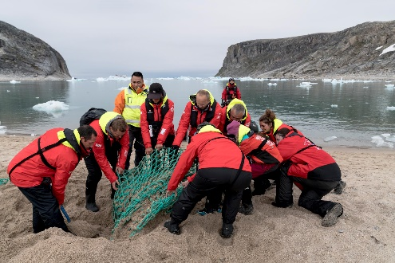 | Cleanups can be a strenuous activity. Some nets are buried so deep it takes a lot of strength to remove them.  Photo by Chelsea Claus, Hurtigruten.
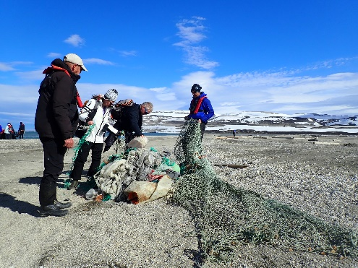 | Picking up waste on shore is a great way for guests to be actively involved in helping the Arctic.  Photo by Zet Freiburghaus, Polar Quest.
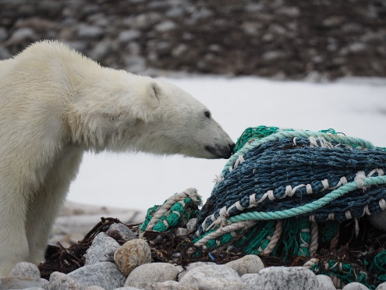 | Marine litter can be a threat to local wildlife.  Photo by Zet Freiburghaus, Polar Quest.
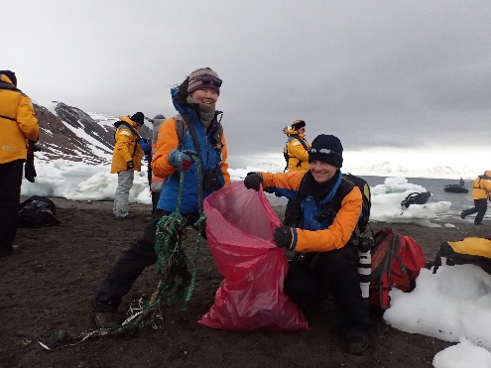 | Beach cleanups give visitors a hands-on experience with environmental stewardship.  Photo by Quark Expeditions.

AECO - Association of Arctic Expedition Cruise Operators
Association of Arctic Expedition Cruise Operators is an international organization for expedition cruise operators and associates in the Arctic, dedicated to managing environmentally friendly, safe and considerate cruise tourism. With close to 70 international members – including 40 vessel operators, owners and management, and 50 expedition cruise vessels that are organized by the association – AECO represent the great majority of these operations in the Arctic.
Website: www.aeco.no.

The Clean Seas campaign
UN Environment launched #CleanSeas in February 2017, with the aim of engaging governments, the general public, civil society and the private sector in the fight against marine plastic litter. Over the next five years, the campaign will address the root-cause of marine litter by targeting the production and consumption of non-recoverable and single-use plastic. By connecting individuals, civil society groups, industry and governments, UN Environment aims to transform habits, practices, standards and policies around the globe to dramatically reduce marine litter and the harm it causes. Website: http://www.cleanseas.org/

