

Press release from Visit Svalbard and AECO - Association of Arctic Expedition Cruise Operators (for immediate release):

Optimal Balance – tourism management workshop in Longyearbyen

September 13, 2019, Longyearbyen, Svalbard

This week a workshop focusing on a balanced approach to tourism development in Svalbard has taken place in Longyearbyen. The event which was spread over three days has seen many speakers and participants join together to discuss, define and pitch research projects that can help Svalbard find the optimal balance in tourist development.

Longyearbyen, Svalbard this week saw over 50 participants gather at Huset to discuss a comprehensive agenda of topics related to tourism. The workshop, organised by The Association of Arctic Expedition Cruise Operators (AECO), the Norwegian Institute of Nature Research (NINA) and Visit Svalbard successfully bought together key researchers from a broad range of fields. These included social science, economics, natural sciences, business, tourism, Arctic issues and preparedness. Representatives from research funding institutions and those working in tourism we also present.

The workshop brought together researchers with an interest for the Arctic who want to help shape the research questions that can contribute to knowledge-based management of tourism in Svalbard and other ecologically sensitive areas. Participants were invited to discuss among others, these main topics; optimal tourism balance, sustainable community development, search and rescue in a tourism context and visitor infrastructure.

“Tourism is and will continue to be an important industry in the Arctic and a valuable source of income for local communities. However, tourism in the Arctic, like in other sensitive destinations, has to be carried out in a considerate manner and bring local benefits. We hope that this workshop will just be a step in a series of initiatives and project that will help ensure knowledge-based management of tourism in the Arctic and other sensitive destinations,” says Frigg Jørgensen, Executive Director of AECO.

According to Trine Krystad of Visit Svalbard, the workshop has proven useful both to the participants and local tourism stakeholders in Svalbard:

“Over the past three days, we have brought together people with different perspectives and areas of expertise. We have identified knowledge gaps and research needs. We hope that the workshop can help inspire new research project that will contribute to sustainable tourism management in the Arctic,” says Krystad.

The workshop also marked the launch of a new study of the economic impact of cruise tourism in Svalbard which shows that Cruise tourism brought Svalbard NOK 110 million (USD 12 million) in earnings in 2018. Both the report and the workshop have been made possible with funding support from Svalbard Environmental Protection Fund.

Suggested illustration photo
High resolution illustration image can be downloaded here:
https://www.dropbox.com/sh/4lyrzwklf52fmnx/AADYZkfu06CH04fqGefIBUEJa?dl=0
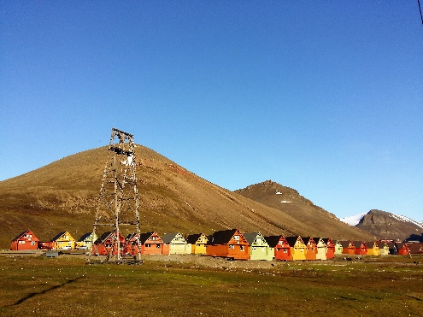 | Participants gathered in Longyearbyen to discuss sustainable tourism in Svalbard. Photo: Frigg Jørgensen, AECO.
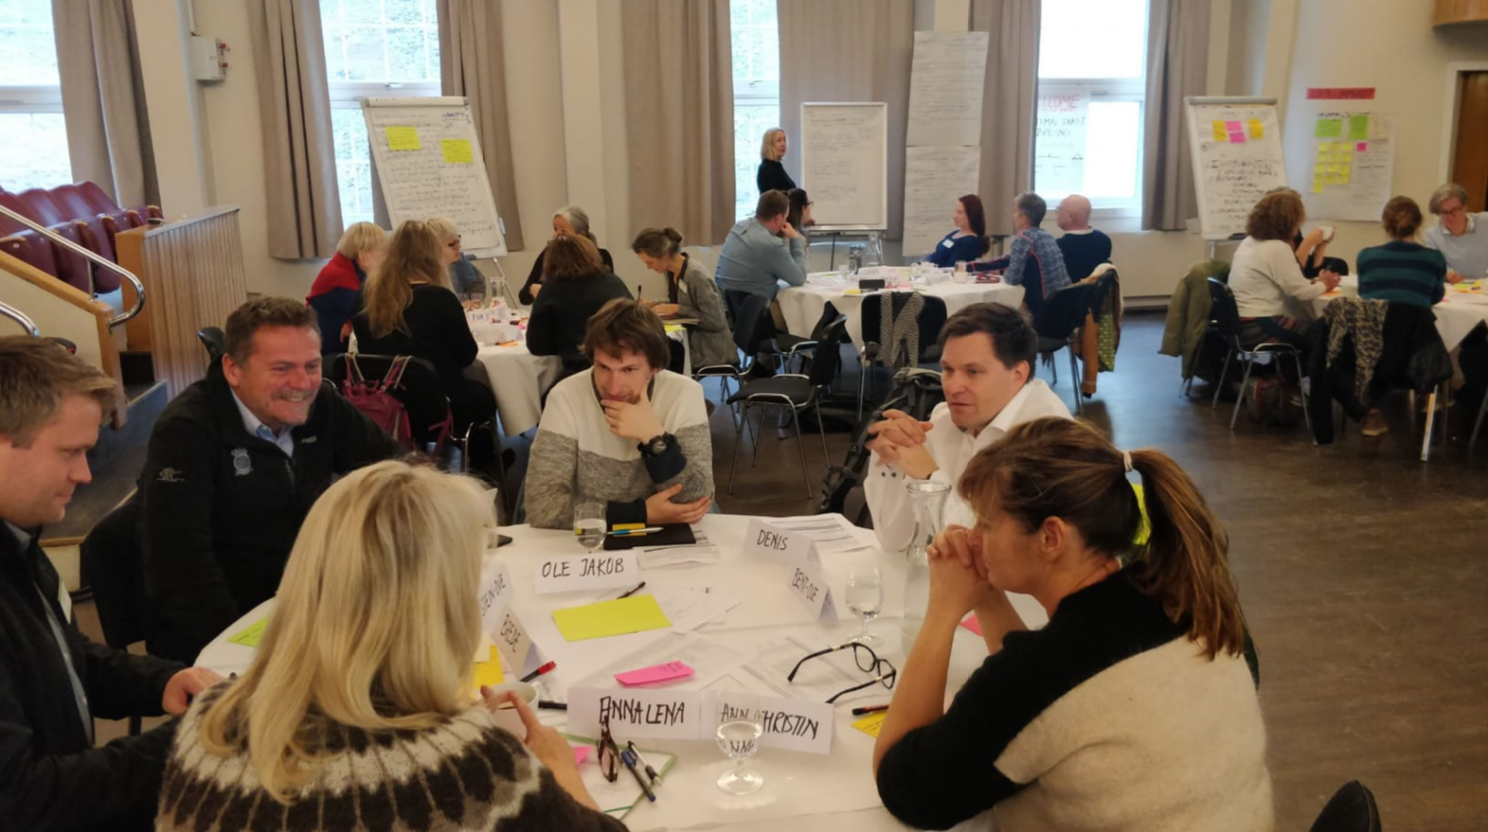 | Group discussions. Photo by Emmi Ikonen.
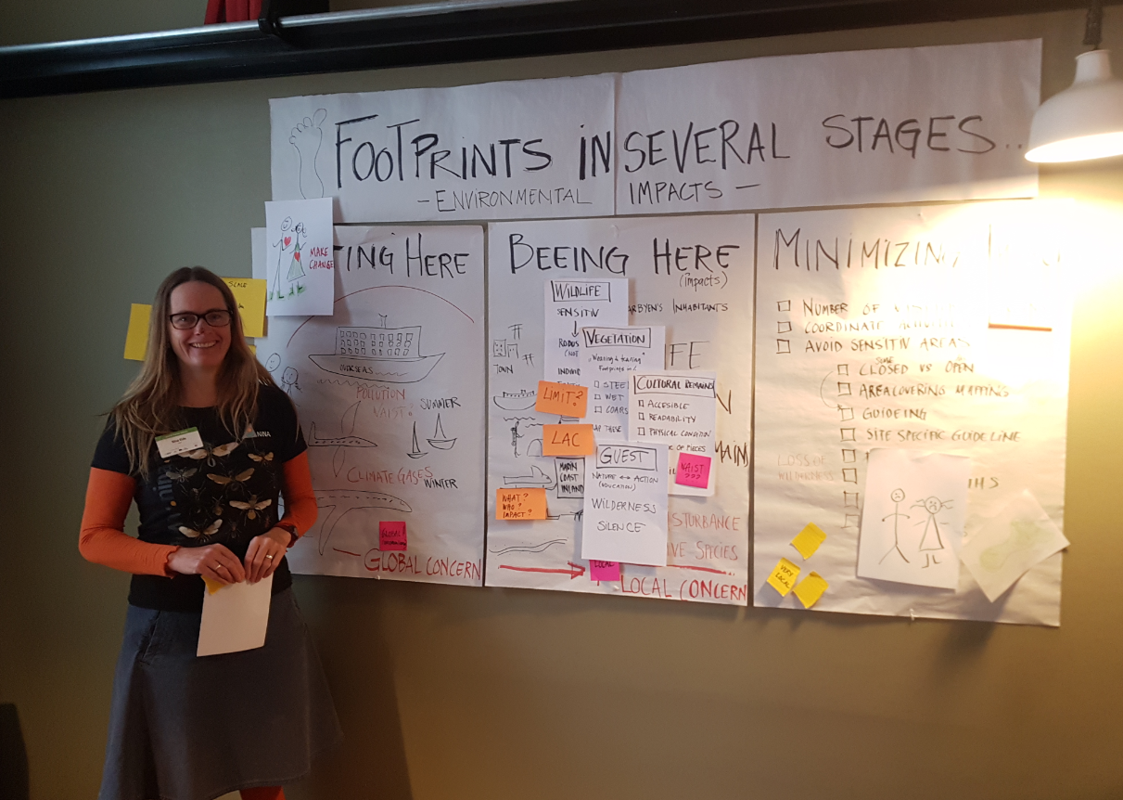 | Presentation. Photo by Frigg Jørgensen, AECO

Contacts
Edda Falk, communications manager, AECO - Association of Arctic Expedition Cruise Operators edda@aeco.no | Cell: +47 476 32 550 | www.aeco.no
AECO - Association of Arctic Expedition Cruise Operators
Association of Arctic Expedition Cruise Operators is an international organization for expedition cruise operators and associates in the Arctic, dedicated to managing environmentally friendly, safe and considerate cruise tourism. With 75 international members – including 46 vessel operators, owners and management, and 60 expedition cruise vessels that are organized by the association – AECO represent the great majority of these operations in the Arctic.
Website: www.aeco.no.
Svalbard Environmental Protection Fund
The Svalbard Environmental Protection Fund was established in 2001 under the Svalbard Environmental Protection Act. The fund's resources will be used to initiate and stimulate projects with the purpose of protecting Svalbard’s environment. The fund is financed by dues and allocation, including the environmental fee paid by all visitors to Svalbard.
Website: http://www.sysselmannen.no/en/Svalbard-environmental-protection-fund/News/Svalbardenvironmental-protection-fund-/
Svalbard Environmental Protection Fund
The Svalbard Environmental Protection Fund was established in 2001 under the Svalbard Environmental Protection Act. The fund's resources will be used to initiate and stimulate projects with the purpose of protecting Svalbard’s environment. The fund is financed by dues and allocation, including the environmental fee paid by all visitors to Svalbard.
Website: http://www.sysselmannen.no/en/Svalbard-environmental-protection-fund/News/Svalbardenvironmental-protection-fund-/

