Press release from AECO - Association of Arctic Expedition Cruise Operators (for immediate release):
AECO hires Marine Operations Agent
AECO is pleased to announce that Mr. Brede Valanes has been hired as AECO’s new marine operations agent assumed the position on April 1, 2019.
Valanes is a certified Master Mariner and has experience from the coast guard, fisheries, oil and gas industry, as well as cruise tourism.
In addition to working at sea, Valanes has worked on maritime regulatory issues and implementation and safety management systems. He has worked with accident prevention and contingency planning and conducted audits and ship inspections. Valanes has also been involved in regulatory processes affecting the maritime industries through forums such as the Norwegian Ship Owners Association.
Valanes has worked as Health, Safety, Environment & Quality (HSEQ) Coordinator for AECO member Hurtigruten, where he was involved in the development and maintenance of a safety management system for vessels and land-based activities. Valanes has also coordinated Polar Code implementation for expedition cruise vessels and contributed to new build projects.
In his position as AECO’s marine operations agent, Valanes will take on tasks connected to the maritime, technical and regulatory affairs that AECO is involved in. The marine operations agent will also be involved in tasks, projects and partnerships related to areas such as operational tools and overviews, search and rescue, hydrography, meteorology/ice, communication, as well as other tasks.
Valanes was selected from a pool of 38 applicants. He is Norwegian and will be based in Tromsø, Norway.
Suggested illustration photo
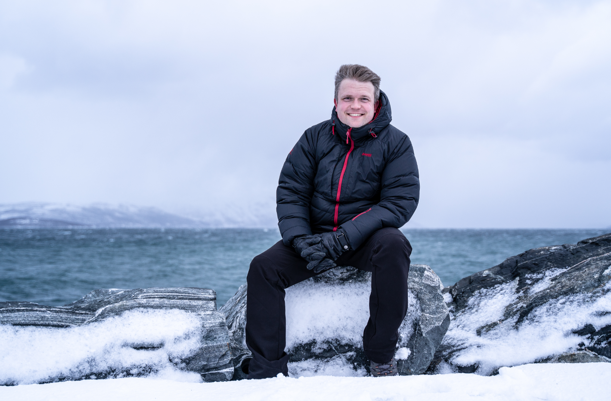 | Photo caption: Brede Valanes, AECO's new marine operations agent. Photo: Linda Nordvåg.  High resolution illustration image can be downloaded here:  https://www.dropbox.com/sh/ervflxl87l3ixao/AAAm-W6scw0gaQJzJyAmDUySa?dl=0
AECO - Association of Arctic Expedition Cruise Operators
Association of Arctic Expedition Cruise Operators is an international organization for expedition cruise operators and associates in the Arctic, dedicated to managing environmentally friendly, safe and considerate cruise tourism. With close to 70 international members – including 40 vessel operators, owners and management, and 50 expedition cruise vessels that are organized by the association – AECO represent the great majority of these operations in the Arctic.
Website: www.aeco.no.

